Kent County Council Capability Fund 2023
Date | 25th September 2023
Report Title | Faversham Cross Town Path 2
EMT Lead | Emma Wiggins, Director of Regeneration and Neighbourhoods
Head of Service | Martyn Cassell, Head of Environment and Leisure
Lead Officer | Adrian Oliver, Active Travel Coordinator
Fund Allocation | £15,000 – Faversham Cross Town Path 2

Swale Borough Council was awarded £40,000 from Kent County Council Active Travel England Capability Fund allocation to enable three projects this year across the borough.
One of these projects, the Faversham Cross Town Path 2, was awarded £15,000. This is a project building on the Faversham LCWIP and successful Active travel Fund 4 (ATF4) bid for the Faversham East-West Cross Town Path.
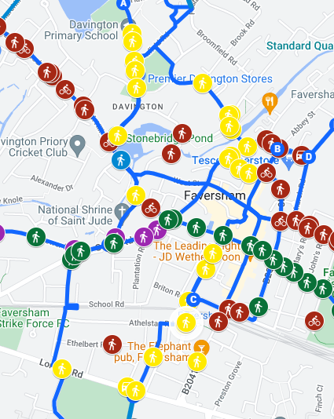
The work is focussing on interventions to create a continuous North-South Cross Town Path. The project will be undertaken in partnership with Faversham Town Council.
So far, a number of interventions have been identified (yellow markers on the map).
The route starts in Davington and North Preston Estate, heads through town and ends at London Road by the Abbey School. An additional intervention at Brogdale Road completes a north south connection to the current East West project.
The full list of proposed interventions to create the North South Cross Town Walking Route is on the next page.
North South Cross Town Walking Route Interventions
LCWIP No. | Intervention | Location | Detail | Design Status
77 | Crossing | Priory Row | Raised Zebra with eastern build out | Concept
76 | Improve Footway | Priory Row | Level Pavement and instal 'Dutch' entrance kerbs. Widen to 1.8m to kerb back. | Concept
6 | Improve Junction | Priory Row/ Road | Tighten junction, narrow road and raised crossing | Concept
75 | Widen pavement | Davington Hill | Widen pavement to 2m | Concept
95 | Crossing | Tanner Street | Extend raised table and install raised zebra crossing. Lose one parking space and build out east side | Concept
9 | Improve Junction | Reedland Crescent | Reduce roads widths - public realm scheme (i.e. seating, trees) | Concept
71 | Improve junction | Bramblehill Road / Church Road | Tighten radii, remove barriers, increase pavement widths, raise crossing | Concept
17 | Crossing | Brent Hill | Continuous crossing over Brent Road | Concept
17 | Crossing | Church Road | Raised crossing itvo Front Brents | Concept
17 | Crossing | Bridge Road | Raised crossing over end of road | Concept
17 | Crossing | Crossing North Lane | Links town centre via Partridge Lane to North Preston | Concept
67 | Pedestrian Improvements | Partridge Lane | Improve link to town centre – wider pavements, raised crossing, filter enforcing TRO | Concept
17 | Crossing | Stone Street | Raised crossing Bank St – Dorset Place | Concept
89 | Lighting | Dorset Place | Ground lighting to enhance security and improve accessibility | Concept
88 | Crossing | Briton Road | Continuous crossing at Forbes Road end of Briton Road | Concept
30 | Crossing | The Mall / Forbes Road | Raised table crossing linking southern residents and students to station | Concept
63 | Extend 20mph | London Road | Extend 20mph speed limit along London Road from Ospringe to Love Lane | Concept
32 | Crossing | London Road | Street level crossing at Abbey School improving accessibility to school and southern housing | Concept
33 | Improve Junction | Canute Road / Kingsnorth Road | Tighten radii, continuous crossing, entry/exit restrictions | Concept
72 | Crossing & junction improvement | London Road / Brogdale Road | Enable safe crossing over London Road | Concept

It is the intention to appoint WSP, who worked on the successful ATF4 bid, undertaking all the detailed construction analysis, costings and provided additional design drawings, to prepare for a future Active Travel Fund construction bid. The appointment would be through the Kent County Council Framework. The aim is to complete the project in 12 weeks.
An additional contribution from Faversham Town Council, through the Active Travel Committee, would enable more detailed drawings of keystone interventions to be generated and potentially some visualisations.
A contribution in the region of £15,000 would be greatly appreciated.
Additionally, as this project is being established as a partnership, knowing how the committee would like this to work, would be helpful.

