ORGANISATION

At the end of March 2021 we had 50 members compared with 54 at the end of March 2020.

OUR FINANCES

This section of the report should be read with reference to the accounts detailed below.
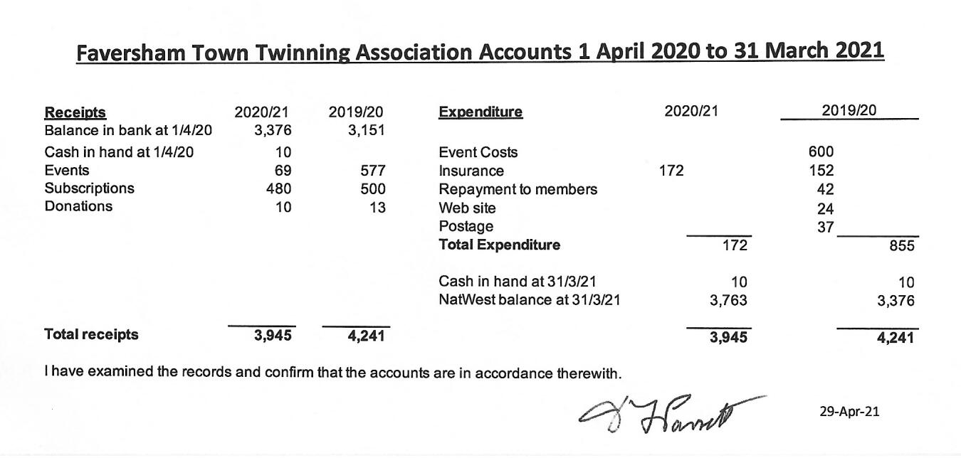
FTTA generated an income of £569 during the period reported on. This income largely came from subscriptions and an event.

Costs amounted to £172, this being the Insurance fee. Our surplus for the financial year was £397 which, added to the balance carried forward of £3,376, means we ended the year with £3,773 to carry forward on 1 April 2021.

In the year 2019-2020 £2,000 of reserves were earmarked to provide financial support to organisations such as schools, youth groups and cultural organisations who wish to visit Hazebrouck. Assessment criteria, outlined in the document on how we will meet our charitable objectives, will be used to ensure we allocate this funding fairly and transparently.

Subscriptions have again covered overheads during this year so the Committee is proposing that the annual individual subscription remains at £10 for 2022/23 and the family subscription remains at £20.

In order to meet charitable objectives and not exclude any local people, membership is free of charge for young people under 18, full-time students and those on pension credit or dependent on other welfare benefits.

Our thanks to Dennis Parrett CBE for examining the accounts.

FINANCIAL CONTROLS

The Association will appoint an Independent Examiner of its accounts if this is thought desirable, if turnover becomes significant, or if it is required to do so.

