Updated 10th May 2021,
list of suggestions of potential Town Centre improvements sent to SBC
 | Item | Description | Status
1 | Ensure Court St & East St gates cannot be bypassed | Position four planters | Completed
2 | Gate signage | Signage on gates to be clear, No Parking or Loading, Emergency Access ONLY | With officers, NOT confirmed
2 | 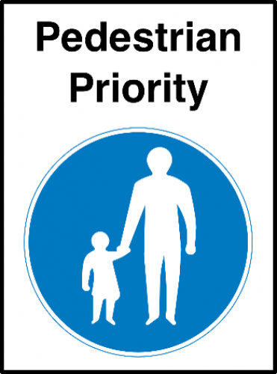  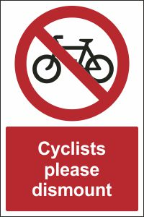 | Road Closed: emergency contact 01795 417xxx  Emergency Access Gate  No Parking or Loading when gates are closed    Drivers may wait in either “Thomas Road ME13 7EN” or “Leslie Smith Drive ME13 7JF”on double yellow lines whilst unloading Max. 20 mins. | With officers, NOT confirmed
2 |  | No Parking at any time  No Loading when gates are closed  Disabled blue badge holders may park on double yellow lines, max 3hrs.  Either “Thomas Road ME13 7EN” or “Leslie Smith Drive ME13 7JF” | With officers, NOT confirmed
3 | Court St. disabled bays | Pending conclusion of the consultation, re-consider disabled bays in the controlled parking zone opposite Ask Restaurant | With officers, NOT yet confirmed
4 | New disabled bays | To be set out in the Partridge Lane and/or Thomas Road car parks | With officers
5 | Cycle Racks | Signage at the cycle racks, markings on the ground? | With officers
6 | Loading Bay | Behind 12 Market Place | Completed
7 | Loading bays | Just outside the pedestrian area, mark out loading bays on Thomas Road | With officers
8 | Free Mobility Scooter Hire | Reconsider post feedback from consultation.  Provide 4xmobility scooters/wheelchairs, with secure lockers. | PENDING result of public consultation
9 | Dropped Kerbs | Locations with officers | AGREED, now with KCC to programme
10 | “Gate” to prevent entry | A form of gate required to prevent vehicles driving through the NO ENTRY signs at the Preston St exit. | With officers for a solution
11 | New and additional  Way-Finding signage | Similar to Sittingbourne TC, but in a heritage style.  Install “Totem” pole info signage. | In development with officers
12 | Forbes Rd underpass | This “gateway” to the Town Centre is the main route into Faversham from the A2 and M2, and is in need of “TLC” | Awaiting sign off
13 | Water bottle refill point | Attached to 12 Market Place | With officers
14 | External Power points | To eliminate the use of diesel electric generators during the “hot food markets” and other evening events. | With officers
15 | Pedestrian area surface | Major repairs need to the red brick and cobbled surface of the pedestrian area. | With officers
16 | West – East cross town walking route  NB Bank Street, X-ing. | Implementation of this pre-designed feature from Napleton Road through to Faversham Recreation Ground. Involves dropped kerbs, informal ped crossing markings, build outs and signage. | With FTC highways designers, and SBC officers.
17 | Cross Lane | Repaint lamp posts and landscaping and tree planting x2 along Cross Lane, adjacent to Central car park | With SBC officers
18 | Raised brick planters | Need a plan to refresh, plant with evergreens, and plant a tree? | With officers
19 | North St informal pedestrian crossing to provide a safe link from North Preston to the Town Centre, and trees on North Lane. | Liaising with Shepherd Neame on their “Street Scape” strategy for around the brewery NB North Lane, Partridge Lane and Conduit Street. | With KCC & SBC officers

