Faversham Front Brents Embankment Routine Maintenance
March 2021
Background
The Faversham Front Brents Flood Alleviation Scheme comprises of a flood defence embankment with a series of access points along its length in which demountable stop logs are placed in times of flood. A condition assessment was undertaken by the Environment Agency’s Catchment Engineer in December 2020 to investigate the current state of the asset and to inform short term remedial actions to ensure the standard of protection is maintained in line with the design criteria.
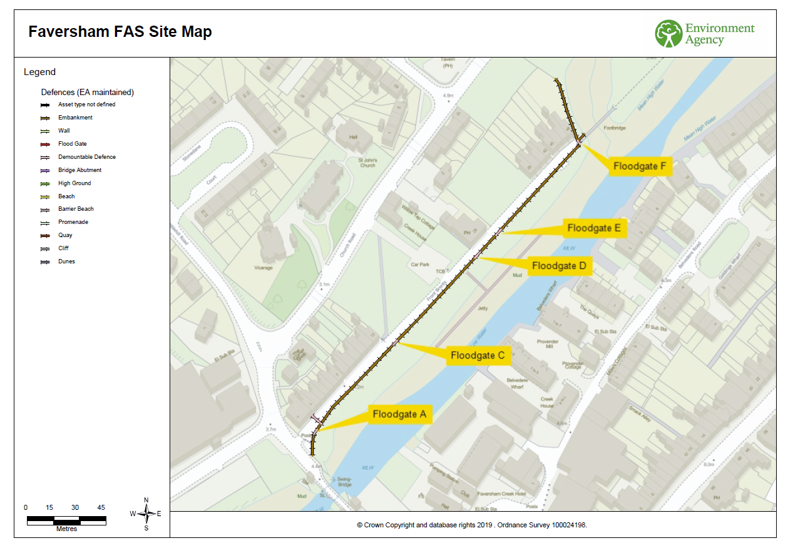
Figure 1: Faversham Front Brents Flood Alleviation Scheme
On the whole the earth embankment (shown as the brown line in Figure 1) is in an acceptable condition however there are localised issues of patchy grass cover, weed infestation and low spots. Since its construction, annual maintenance of the embankment (mowing/strimming) has been undertaken by Swale Borough Council, however the Environment Agency is proposing to take over future maintenance and intends to carry out the following:
- Targeted weed spraying of weed infested areas. Figure 2 show where weed infestation is resulting in bare patches of earth along the embankment. The aim is to use herbicide in the worst affected areas as a one-off activity in 2021 to prevent further weed growth. The areas will then be reseeded.
- Twice yearly grass mowing/strimming (in late April/early May and late September/early October).
- Topping up of lows spots where the embankment has settled to provide a uniform crest height
- Minor tree maintenance to the lower limbs of the willow trees which are currently blocking sunlight and preventing sufficient grass cover. This is subject to discussions with UKPN due to the proximity of overhead power lines.
- Reseeding those areas where grass cover is insufficient.
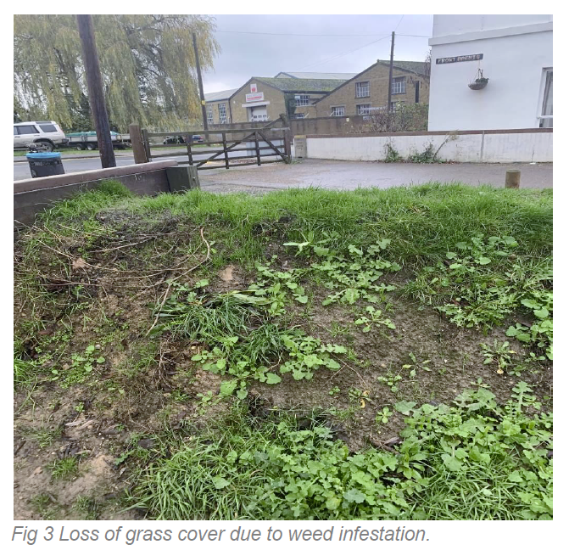
Figure 2: Loss of grass cover due to weed infestation
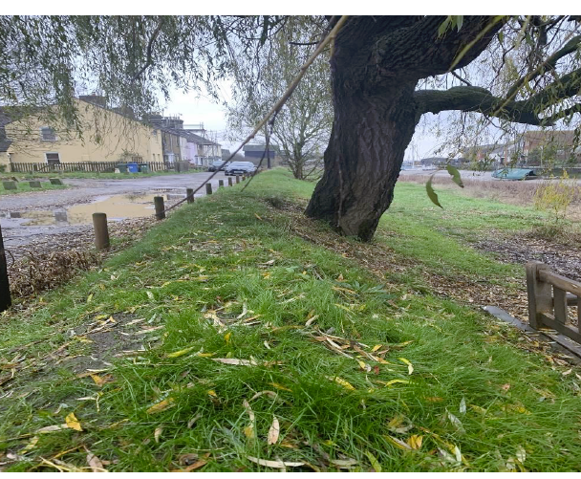
Figure 3: Large willows impeding grass growth

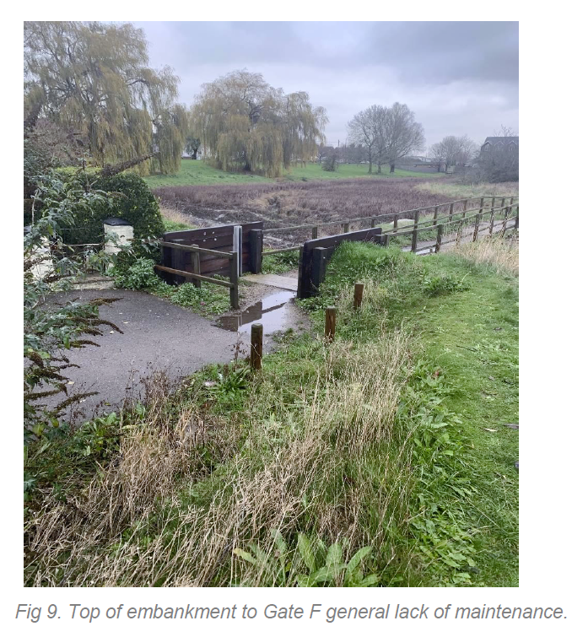
Figure 4: General lack of maintenance
Reasons for maintenance
Routine mowing and maintenance of earth flood embankments is essential to maintain the grassy composition of the vegetation and to stop scrub and weeds from encroaching. Grass acts as protection from soil erosion and has to be kept short to ensure it forms dense grass sods, which help to preserve the structural integrity of the embankment. The shorter grass sward allows visual inspection of the embankment and is also more resilient to erosion from overtopping water and heavy rainfall, as water can flow smoothly across the grass. The landward face of the embankment is especially important; if the sward is left too long or if deep-rooting plants or shrubs are allowed to establish, these weaken the structure and are more susceptible to being eroded around and pulled out by water during a flood event. This increases the risk of asset failure and potential breach of the flood defence.
At Faversham, we intend to mow the embankment twice a year, in late April/early May and late September/early October when the ground is dry; this will ensure sufficient flood risk protection throughout the year. We will cut the crest, front face and landward face of the embankment (bund) only; we will not mow the surrounding grassed area. We will also start later in the day to safeguard reptiles as this allows them time to warm up and move away from the area. We do not undertake patchwork mowing, where grass is cut at different lengths, as this can result in more damage in the event of the sea wall overtopping, as described above.
The methods described are carried out in line with the rest of our sea wall/earth embankment maintenance programme carried out across the Swale estuary area. The timing and the methodology of our maintenance programme is assessed by the Environment Agency’s biodiversity team taking into consideration pollinators, bird nesting seasons and other environmental impacts. Where applicable, the programme is sent to Natural England for their assessment and assent as a vast number of our sites are within designated areas (Swale Site of Special Scientific Interest (SSSI), Special Protection Area (SPA) and Ramsar sites). We only ever mow the embankments in line with biodiversity guidance and the assent issued to us by Natural England, and the timing of the mowing programme is established taking into consideration the needs of flood risk management and biodiversity.

