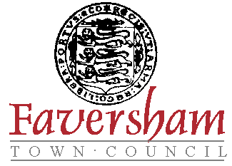

Action Plan
2021 - 2022

The following Action Plan summarises the Town Council’s activities and projects it will commence or complete during 2021 and 2022.

1. | A town-wide 20mph scheme  - Deliver a town-wide 20mph scheme
2. | Improve cycling and walking  - Deliver a Local Cycling and Walking Infrastructure Plan (LCWIP)  - Enhance walking routes with signage to aid connectivity  - Continue to encourage cycling and walking through community engagement and events
3. | Climate and biodiversity  - Encourage biodiversity in areas of local authority ownership  - Work with Faversham residents to increase biodiversity in their back gardens  - Promote climate emergency awareness through activities and events
4. | Engaging with all youth, particularly those who are harder to reach  - Identify potential partnerships  - Develop a youth engagement plan
5. | Diversity and equality  - Support a fairer Faversham by making equality and diversity issues a priority at all levels of the Council as a key part of the decision-making process  - Ensure that facilities and events are accessible and welcoming to all communities  - Foster greater community cohesion by creating a town where difference and diversity is understood, celebrated and valued  - Seek to implement, where possible, recommendations made by the Electoral Commission or other independent bodies aimed at reducing barriers to standing for election to this council
6. | Neighbourhood plan  - Continue to develop a neighbourhood plan  - Carry out extensive consultation through community engagement  - Present a neighbourhood plan which will be successful at referendum
7. | Homelessness  - Develop ways to assist the homeless in Faversham  - Support the Faversham Community Land Trust  - Ensure truly affordable housing is included in the developing neighbourhood plan
8. | Sports Council  - Identify local groups and provide a networking hub  - Ensuring sport and physical activity is included in the developing neighbourhood plan  - Develop Active Faversham, encouraging the community through events and activities
9. | Lobby both public and private bodies to gain the best for Faversham, within whose responsibility lies the following  - An opening Creek bridge  - Better engagement with Kent Police, British Transport Police and Swale Borough Council, around the occurrences and perception of anti-social behaviour
10. | Community Groups, Spaces and Events  - Enhance the cultural offer by developing a permanent exhibition of the town’s Magna Carta  - Encourage community creativity and cohesion by enabling local groups to meet or exhibit for free in the Guildhall and 12 Market Place  - Provide grants for local community events and groups

The Town Council will continue to review its Action Plan during the coming months to ensure it is still appropriate.

